Customer Status User Manual

Table Of Contents

1 What is the Customer Status? 1
2 How is the Customer Status Calculated? 1
3 Using the Customer Status History Component 2
4 User Roles 3
5 Defining “Required Actions” at the User Role Level 3
Appendix A – Customer Status Criteria 4
Appendix B – Default Action Descriptions 5

What is the Customer Status?
The customer status is a feature to help categorise the quality of a customer (account holder), at any particular moment in time. It will also help flex users deal with customers as the Customer Status History component, figure 1, describes the appropriate action to be taken by the user when dealing with a customer, of a particular customer status. The status ranges from AAA (highly valued customer) down to L (lost customer).

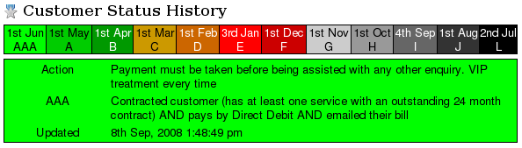
Figure -1 - Customer Status History Component

How is the Customer Status Calculated?
All non-archived accounts will be assigned a customer status for each invoice run, regardless of whether or not they actually had an invoice generated in the invoice run. This status will be calculated once a day, for the first 40 days after an invoice run is committed; after which the status will not be changed for that particular invoice run/account combination.
Each status has a specific set of criteria that must be met by the customer in order to be awarded the status. A complete list of the criteria for each customer status can be found in Appendix A. A description of the criteria is displayed in the Customer Status History control (figure 1), next to the status' name.
The statuses are tested in reverse order of the customer quality that they represent. That is to say, an account is evaluated to see if it meets the criteria of status L first, then status J, and so on up to status AAA. It will be assigned the first status it satisfies. This means that if an account satisfies all the criteria for status AAA, but also satisfies all the criteria for J, it will be awarded status J.
An account will always satisfy at least one of the statuses.

Using the Customer Status History Component
The Customer Status History component can be found on Flex's Account Overview page. It is broken up into two noticeably different parts. The top part displays the history of the account's customer status, for the last 6 invoice runs, ordered by the billing date of the invoice run.
The bottom part displays details relating to a particular customer status allocation. By default, it will display the specific details of the customer status relating to the most recent invoice run. To view the details of any of the older invoice runs, hover the mouse over the invoice run / customer status in question, and the details will be displayed.
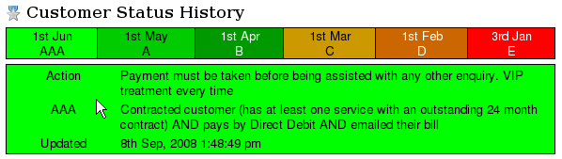
Figure -2 - Customer Status History Component (default display)
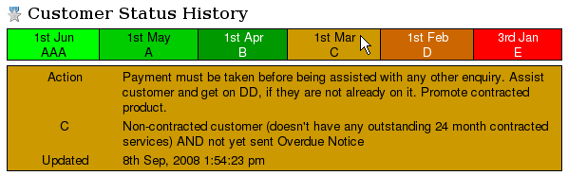
Figure -3 - Customer Status History Component
(showing details of customer status relating to the March 1st invoice run)
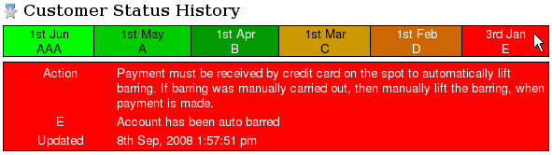
Figure -4 - Customer Status History Component
(showing details of customer status relating to the January 3rd invoice run)
Note the location of the mouse pointer in figures 2 to 3.
The user should usually only be concerned with the customer status relating to the most recent invoice run.
The details section displays:
- The action required of the user
- The description of the customer status. (Describes the criteria for the status)
- The timestamp of when the status was last calculated for this particular invoice run / account
The required action can be specific to the customer status, the, “role”, of the user and whether or not the account currently has an outstanding overdue amount.
For example, if the account has an overdue amount, the required action will usually say, “payment must be taken” as well as any other actions pertaining to the customer status.

User Roles
Each employee can now be assigned a user role, which broadly defines their job description. This is currently only used so that the “Required Action” displayed in the Customer Status History component can be specific to the role of the user. Default “Required Action” descriptions are defined for each customer status, and will be used when “Required Action” descriptions specific to the user's role have not been defined.
For example, if the customer has a status of G (Account is ready for Austral but has not gone there yet) and the user has their Role defined as “Customer Service Representative”, the required action will be displayed as, “Customer to be handled by Credit Control department”. However, if the user has their Role defined as “Credit Control Manager”, their required action will be different and specific to the role of the Credit Control Manager.

Defining “Required Actions” at the User Role Level
The “Required Actions” specific to each customer status / user role can be modified from within the Customer Statuses page, which can be accessed through the Admin dropdown menu, assuming you have the Super Admin permission.
Admin -> System Settings -> Manage Customer Statuses
From here you can View and Edit the individual Customer Statuses.
Note that currently the only details that can be edited are the default “Required Action” descriptions and the User Role Specific “Required Action” descriptions. No other details regarding the Customer Statuses can be changed.
The default “Required Action” descriptions are defined in Appendix B.

Appendix A – Customer Status Criteria
Order of Precedence | Name | Criteria
1 | L | Lost Customer (all services lost)
2 | J | T.I.O issue pending
3 | I | Account has dispute with invoice
4 | H | Account has gone to Austral
5 | G | Account is ready for Austral but has not gone there yet
6 | F | Final Demand has been sent (implies TDC has been applied)
7 | E | Account has been auto barred
8 | D | Overdue Notice has been sent
9 | C | Non-contracted customer (doesn't have any outstanding 24 month contracted services) AND not yet sent Overdue Notice
10 | B | Contracted customer (has at least one service with an outstanding 24 month contract) AND not on Direct Debit AND not yet sent Overdue Notice
11 | A | Contracted customer (has at least one service with an outstanding 24 month contract) AND pays by Direct Debit AND not emailed their bill
12 | AAA | Contracted customer (has at least one service with an outstanding 24 month contract) AND pays by Direct Debit AND emailed their bill

Appendix B – Default Action Descriptions

Status | Required Action | Required Action when customer has outstanding overdue amount
L | Attempt win back | Collect any outstanding monies and attempt win back
J | This account cannot be credit managed or barred. Handled by Customer Service Manager only | This account cannot be credit managed or barred. Handled by Customer Service Manager only
I | Dispute handled by CSM or TL | Collect undisputed amount (overdue amount). Dispute handled by CSM or TL
H | Customer to be handled by Credit Control department | Customer to be handled by Credit Control department
G | Customer to be handled by Credit Control department | Customer to be handled by Credit Control department
F | Incoming call from customer must be redirected to Credit Control department | Incoming call from customer must be redirected to Credit Control department
E | Lift barring if manually barred | Payment must be received by credit card on the spot to automatically lift barring. If barring was manually carried out, then manually lift the barring, when payment is made
D | Assist with any enquiry | Payment must be taken before being assisted with any other enquiry
C | Assist customer and get on DD, if they are not already on it. Promote contracted product | Payment must be taken before being assisted with any other enquiry. Assist customer and get on DD, if they are not already on it. Promote contracted product
B | VIP treatment every time | Payment must be taken before being assisted with any other enquiry. VIP treatment every time
A | VIP treatment every time | Payment must be taken before being assisted with any other enquiry. VIP treatment every time
AAA | VIP treatment every time | Payment must be taken before being assisted with any other enquiry. VIP treatment every time

